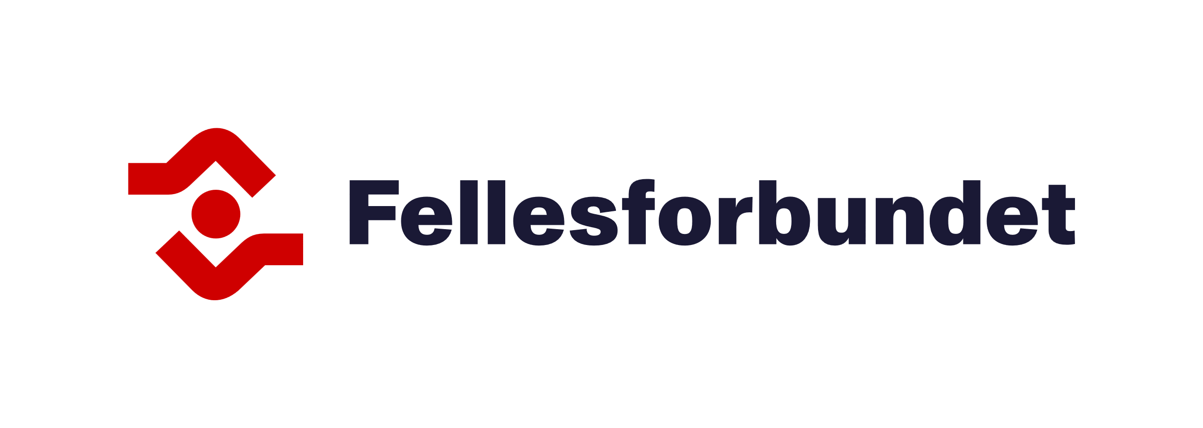
Our Main Demands in This Year's Negotiations

The 2026 pay negotiations

Get More Out of Your Pay!
The Executive Board of Fellesforbundet has decided that the goal for the negotiations, when it comes to money, is that every worker should have more in pay rise than the prices have risen last year. The result will come as fixed-sum increases. This means everyone receives the same rise in Norwegian Kroner, regardless of current salary levels. This helps reduce inequality.
We will also negotiate to secure additional increases for agreements and groups that either have low wage levels or have experienced weak wage development over time.
Advance Payment of Sickness Benefits!
Today, employees on sick leave risk being without income while NAV processes their sickness benefit application. This poses a significant financial risk for those who are ill. If the employer pays the amount NAV would normally provide and is later reimbursed by NAV, the sick employee can focus on recovering instead of worrying about when money will arrive in their account.
Paid Leave
The Executive Board of Fellesforbundet has also adopted a demand to strengthen the right to short welfare leave. One specific demand is the right to paid leave to accompany children under the age of 12 to the doctor, health clinic, or dentist. These demands have been submitted by many clubs and departments!
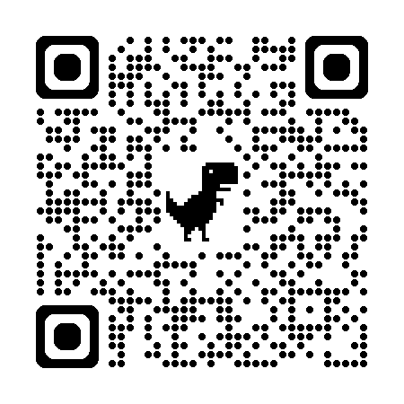
Become a member of Fellesforbundet!

